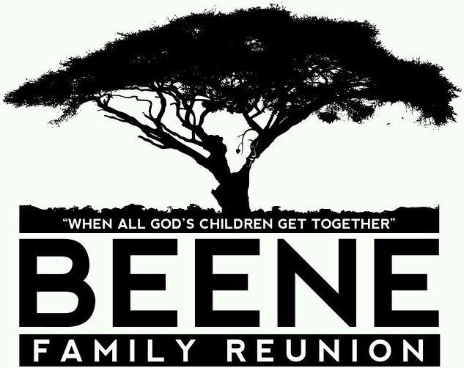
BEENE FAMILY REUNION
10 FAQ’s (Frequently Asked Questions)
Who are we? The Beene/Bean family is direct descendents of our patriarch, Phillip Beene. One of the first “Beene” family reunions was held on July 4, 1961 in Milwaukee WI hosted by sisters and brothers of the late Leander Beene Sr, descendent of Calvin and Caroline Beene.
- When are the reunions held?
  - Typically, the reunions are held the third weekend in July.

- How many people attend?
  - We generally have approximately 225+ participants from various states.

- How long is the family reunion?
  - For the most part, just two days-- Friday & Saturday. Sundays are worship services that are welcomed to all.

- How much does it cost?
  - Reunion registration fees are tiered by age groups, discounted costs for children under 5 and seniors over 80. Some of our past reunion fees have ranged from $35- $75 for the two day event & decided my host city.

- What does the fee include?
  - These charges are varied by the host committee. It may include: hotel and catering fees, meals/food, T-shirts, rentals, transportation, postage, speakers, gift bags, paper good products/supplies (to name a few)

- Can I just participate and pay for one day of the reunion?
  - It was decided by our reunion committee that an “al a carte” payment will not be allowed due to difficulty in budgeting and tracking. However, if extenuating circumstances and at the discretion of the host, perhaps a partial refund will be allowed if a full payment was submitted. Again, this is on a case by case basis.

- How are family members notified?
  - Reunion website www.bean2beenefamilytree.com has lots of good information. One can access the “Beene Family” on Face book and join our group to give and receive updates. Information is sent through personal email accounts as well as postcards, letters and phone calls. It is very important to keep us updated with your current address/phone, email address or Face book name so that we may continue to bring current information to you.

- What goes on at the family reunion? Is there something for me to do?
  - Friday nights are generally saved for the “Meet & Greet”. This includes family registration, usually the distribution of T-shirts and/or souvenir bags and refreshments. Some fun activities may include, (icebreakers, games, singing) and getting reconnected with your family while meeting new family.
  - Saturday reunion day may consist of a tour, family picnic, & evening banquet with talent show. Other activities may involve sporting activities (basketball, football etc.) or activities for children such as face-painting or having a clown or magician. These activities will vary and are at the discretion of the host city.

- Where were some of the reunions held?
  - Various states---Wisconsin, Tennessee, Illinois, Ohio, Mississippi, Georgia, Louisiana, Michigan, Missouri and California.

- Where are the next family reunions going to be held?
  - July 2014---Chicago, IL 2015---Milwaukee, WI 2016-TBD

